Acids and Bases

# Properties of Substances

## Acids:

* Conduct electrical current
* Turns blue litmus paper red
* Has a sour taste
  + Most metal oxides have low solubilities (low K value)

## Bases:

* Conduct electricity
* Turns red litmus paper blue
* Has a soapy feel

## Data Sheet

* All Metals are silvery grey unless specified by data sheet as **Other Coloured Substances**
* Look at top table to determine colour as a solid
  + If solid is not present in table, go to end table. If it contains an ion from bottom table, solid takes its colour
* Look at bottom table to determine colour of aqueous substance
  + Solids often take colour as aqueous ion
* Look at third table to determine colour of free halogen (not mixed)
* Look at fourth table to determine colour of aqueous halogen
* Fifth table shows colour of halogen in organic solvent

## Terminology

* Acids are proton donors
* Bases are proton acceptors
* Alkali are soluble bases
* A strong acid is a substance that fully ionizes in solution and is a proton donor
* A weak acid is a substance that partially ionises in solution and is a proton donor
* A concentrated acid is a substance with a high number of acid moles per unit volume
* A diluted acid is a substance with a low number of acid moles per unit volume

## Strength

* Substances can be both weak and concentrated/strong and diluted
* Strong acids are:
  + HNO3
  + H2SO4
  + HCl
* Weak acids are all other proton donors
* Strong bases are:
  + Group 1 and 2 metal oxides and hydroxides
* Weak bases are all other proton acceptors
* includes:
  + NH3 which is a base
  + H3PO4 which is weak acid
  + HF which is weak acid
  + HSO4- which is amphiprotic, but tends to be an acid
  + H2PO4- ⇒ amphoteric, tends to be acidic
  + HPO4- ⇒ amphoteric, tends to be basic
  + HC2O4- ⇒ tends to be acid
  + HCO3- ⇒ tends to be basic
* To determine strength of a substance, separate substance into ions then perform hydrolysis with acidic/basic substance

# Acid-Base Reactions

$Acid+Base→Salt+water$ $$Acid+Metal→Salt+H_{2 \left(g\right)}$$ $Acid+Metal Sulfite→Salt+water+SO_{2 \left(g\right)}$ $Base+NH_{4}^{+}→Salt+water+NH_{3}$ $Base+non metal oxide→Salt+water$

* Non-metal oxides are acidic (ex. SO2 or CO­2), as they react with H2O to form an acid (ex. H2CO3 or H2SO3), which ionises

# Brønsted-Lowrey Theory

* Acid-base reactions are reversible
* Acids are proton donors
* Bases are proton acceptors
* **-no contrasting questions between BL and Arrhenius will come up (older questions)
* H3O+⇒H+⇒proton

## Conjugate Acid-Base Pair

$$A^{'}+B^{'}→A+B$$

* If A’ is acid, A is conjugate base
* If B’ is base, B is conjugate acid
* A’ and A are conjugate pairs $(A'|A)$
* B’ and B are conjugate pairs $(B'|B)$

## Amphiprotic

* Substances that can both donate and accept protons ⇒ amphiprotic
* Substances that can react as acid or base ⇒ amphoteric
  + All amphiprotic substances are amphoteric, but all amphoteric substances are not necessarily amphiprotic
  + Amphiprotism ⇒ Amphiterism NOT Amphiprotism ⇔ Amphiterism
  + Ex. Al2O­3 is amphoteric, but not amphiprotic ⇒ cannot donate protons
* An amphiprotic substance will act as an opposite (acid/base) to the other substance
* Polyprotic acids that have a mid-charge are amphiprotic

## Solubility/Strength

* Use K to determine whether amphiprotic substance is more acidic or basic
* Carbon-based organic acids are generally weak
* Conjugate of strong substance is weak

## Polyprotic

* Polyprotic substance donate multiple protons in solution
* K decreases with each donated proton:
$$K_{1}>K_{2}>K_{3}…$$

* Number of protons present provides no info about strength

## Self-Ionization of Water

$$K_{w}=\left[OH^{-}\right]\left[H_{3}O^{+}\right]={10}^{-14} \\ {2H}_{2}O_{←}^{→}H_{3}O^{+}+{OH}^{-} \\ \left[H_{3}O^{+}\right]=\left[OH^{-}\right] \\ ∴{\left[H_{3}O^{+}\right]}^{2}={10}^{-14} \\ ∴\left[H_{3}O^{+}\right]={10}^{-7}$$

* Reaction is endothermic
  + Therefore, when temperature increase [products] will increase
  + Therefore, [H3O+] increases, hence, as pH=-log[H3O+], pH decreases
  + However, solution remains neutral as [H3O+]=[OH-]

## Hydrolysis

* Hydrolysis is the reaction between substance and water to produce an ion
* Model answer:
  + Hydrolysis of A’ (proton donor) produces H3O+ in solution when reacting with H2O (proton acceptor). Therefore, A’ is an acid
    - Supported by equation
* **HCO3-, CO32-, HPO42-, PO43- and SO42- an bases**
* **HSO4-, H2PO4- and group 13 metals are acids**

## Buffers

* A buffer is a solution that resists changes in pH when a small amount of acid or base is added
  + Ex. Weak acid and its conjugate base
$$CH_{3}COOH|CH_{3}COO^{-}$$

* Buffering capacity is the extent to which a buffer resists change in pH, when a small amount of acid or base is added
  + Substances that have higher buffer capacities are better buffers

### Factors that affect buffering capacity include:

* Exact concentration of each solution
* Relative concentration of each solution
  + Aquimolar amounts of acid and conjugate base is required, or buffering capacity will be low
* Type of chemical used

### How to explain Buffer chemistry

* Acid added
  + Always start with acid hydrolysis
 $$x^{'}+H_{2}O{}_{←}^{→}{x+}H_{3}O^{+}$$

 + When acid added, [H3O+] increases
  + Therefore, equilibrium shifts to the left to partially oppose the change in [H3O+] according to LCP (reverse reaction favoured)
  + Therefore, most of the H3O+ added is removed
  + Therefore, change in [H3O+] will be negligible
  + Therefore, as pH=-log[H3O+], change in pH will be negligible
  + Therefore, pH will be maintained within a narrow range
* Base added
  + When base is added, [OH-] increases, which reacts with H3O+ to form H2O (neutralisation reaction)
* Therefore, [H3O+] decreases… {continue with previous equilibrium explanation}

### Making Buffers

* Buffers are made from a weak acid and its conjugate base or weak base and its conjugate acid
* A weak substance and its conjugate is added in equal concentrations

### Double Equation Explanations

* After explaining buffer for acid added with equation:
$$A^{'}+{B^{'} }_{←}^{→} A+B$$

* Write equation:
$$A+{B }_{←}^{→} A^{'}+B'$$

* Such that conjugate (A) of initial reaction (A’) is in forward reaction
* Then explain for base, using conjugate

# pH Calculations

* Assume 100% ionization for all pH questions

$$pH=-log⁡[H^{+}]$$

# Primary Standard Solutions

* PSS are substances that have an accurately known concentration
* Prepared by weighing sample of PSS, dissolving in distilled water, then increasing volume to a precise value in a volumetric flask
* PSS must:
  + Be able to be obtained in a very pure form consistent with its chemical formula
  + Be sufficiently stable so that on exposure to air, it doesn’t change its water content or react with CO2 in the air
  + Have a relatively high molar mass
* Substances that do not fulfill PSS criteria must be standardised through a titration, and it can be used as a secondary standard solution
* Secondary standard solutions are not as accurate as PSS and therefore have higher uncertainty

# Acid-Base Titration

* Carefully measured volume of one solution (aliquot) is added to a conical flask
* Variable volume of known concentration (titre) is added from burette to conical flask until acid-base reaction is complete
* Equivalence point occurs when neither acid nor base is remaining
* End point occurs when indicator has changed colour to indicate equivalence has occurred
* Equivalence point must be very close to end point for the titration to be accurate
  + Therefore, suitable indicator must be chosen specific to substances used

# Performing Titrations

1. Aliquot volume is carefully measured with pipette (usually 20mL)
2. Solution is transferred to a clean **conical flask** that has been **pre-rinsed with distilled water**
3. Few drops of suitable indicator are added to conical flask
4. Titre is placed inside **burette** that has been **pre-rinsed with the titre**
5. Reagent is then released in a controlled way from burette into conical flask
6. When indicator changes colour, no more titre is added

* Back titration is similar to normal titration, except instead of aliquot consisting of substance to be determined, aliquot consists of excess hydrogen or hydroxide ions from a reaction with the unknown substance.

# Indicators

* Phenolphthalein is a basic indicator (8.3-10)
  + Colourless in acidic solution
  + Pink in basic solution
* Methyl orange is acidic indicator (3.1-4.4)
  + Methyl Orange ⇒ ROY (Red (acid), Orange (equivalence point), Yellow (base))
* To determine which indicator used, do hydrolysis of salt formed at equivalence point. Basic means phenolphthalein, acid mean MO
* Answer structure:

1. [Base] is strong base, [Acid] is weak acid
2. At equivalence point, basic salt is produced ([salt])
3. Hydrolysis of [salt] (proton acceptor) forms OH- ions in solution, when reacting with water (proton donor)
$salt+H_{2}O_{(l)} {}_{←}^{→}{ salt dissociated}+{OH}_{(aq)}^{-}$

4. Therefore, equivalence point will be higher than seven (ex. around 9), as OH­- ions are produced
5. Phenolphthalein has equivalence point at 8.3-10, therefore, phenolphthalein is a suitable indicator

* Use pH curve to support answ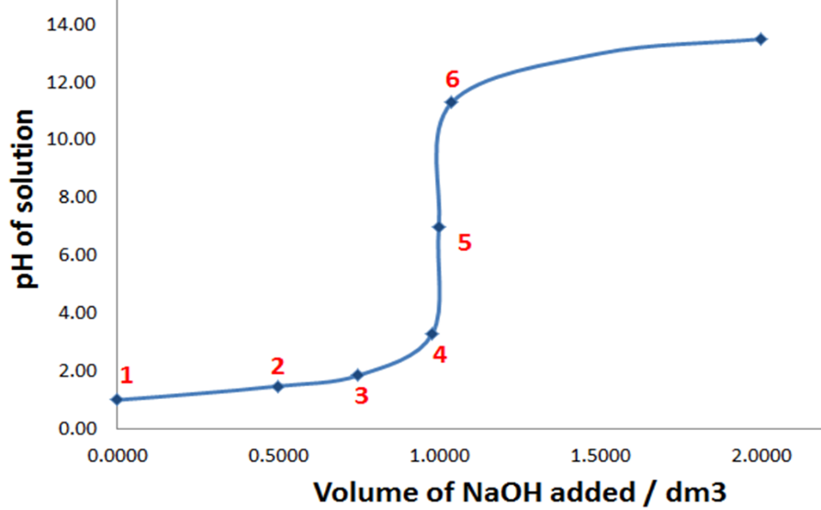er:

Errors in titrations

* ▪ Systematic errors cause lower accuracy
* Use correct technique to eliminate
* Examples
* Faulty balance
* Some of substance/solution being left in original container
* Primary standard inflated due to having absorbed water
* ▪ Random errors cause lower precision
* Minimise by averaging several titre values - don't include outlier/anomaly
* Can never be eliminated
* Examples
* Uncertainty in measurements (last value after decimal place) - includes

scales

* Whether meniscus sits on line when using pipette

# Back Titration

* Back titrations
  + When to use
    - One reactant is volatile (ammonia)
    - Acid/base is insoluble salt (calcium carbonate)
    - Reaction is too slow
    - Weak acid/base titration (no clear end point to approximate equivalence)
  + Method
    - React acid/base with a known amount of an excess reagent (standard solution that is a strong base/acid)
    - Excess reagent remaining is titrated with a standard solution that is a strong acid/base to determine the number of moles of the excess reagent remaining
    - Subtract this value from the initial number of moles of the excess reagent to give the number of moles that reacted with the unknown acid/base
    - Thus, can work out the number of moles and concentration of unknown acid/base in original substance